1. Create an ER diagram or draw a schema for the given database.

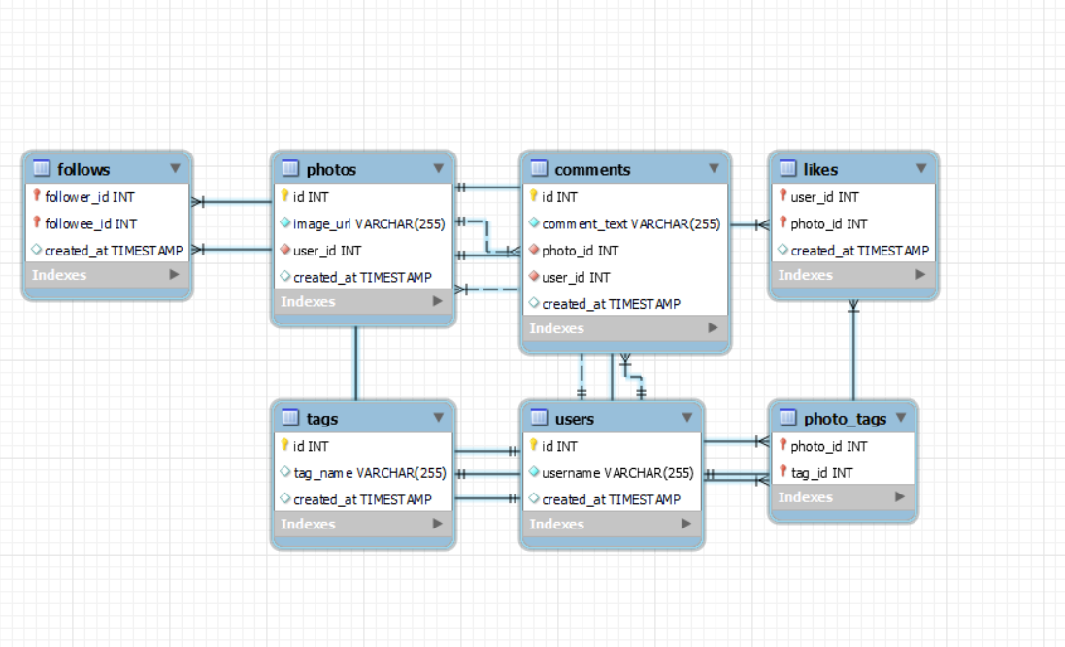

2. We want to reward the user who has been around the longest, Find the 5 oldest users.

Ans: SELECT * FROM ig_clone.users order by created_at limit 5 ;

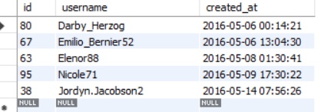

3. To understand when to run the add campaign, figure out the day of the week most users register on?

Ans:

WITH CTE_NoOfDays

AS

(SELECT username, created_at, dayofweek(created_at) noOfDays FROM ig_clone.users order by dayofweek(created_at) )

Select case when noOfDays =1 then 'Sunday'

when noOfDays =2 then 'Monday'

when noOfDays =3 then 'Tuesday'

when noOfDays =4 then 'Wednesday'

when noOfDays =5 then 'Thursday'

when noOfDays =6 then 'Friday'

when noOfDays =7 then 'Saturday' end as DayUsersMostRegisteredIn

from CTE_NoOfDays group by noOfDays order by noOfDays desc limit 1;

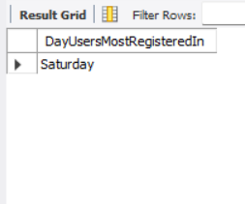

4. To target inactive users in an email ad campaign, find the users who have never posted a photo.

Ans:

Select u.id, u.username from users u Left join photos p

on u.id = p.user_id

where p.user_id is null;

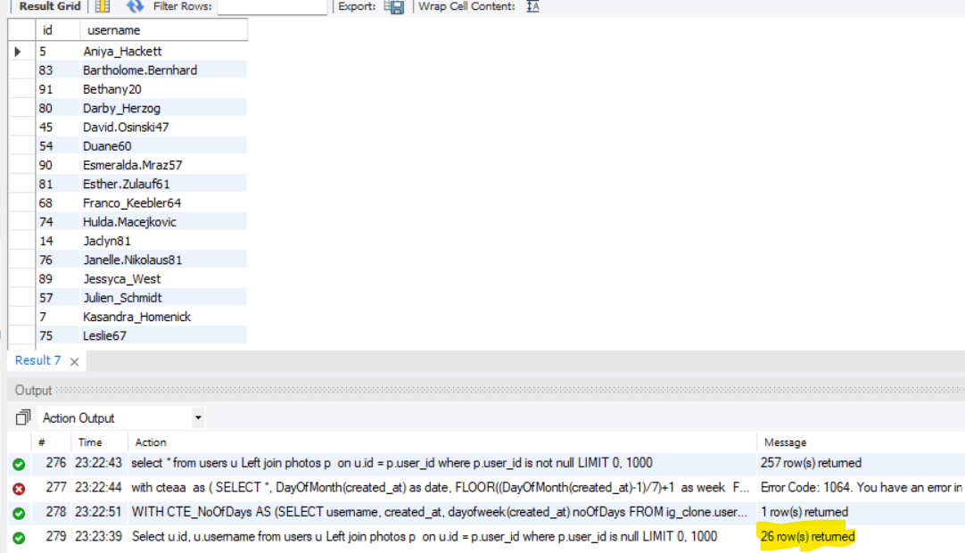

5. Suppose you are running a contest to find out who got the most likes on a photo. Find out who won?

Ans:

with likesCount

as

(SELECT photo_id, COUNT (*) AS like_count FROM likes GROUP BY photo_id)

select p.user_id,c.like_count,u.username,p.image_url photoname from likesCount c

inner join photos p

on p.id =c.photo_id

inner join users u

on u.id = p.user_id

order by c.like_Count desc limit 1

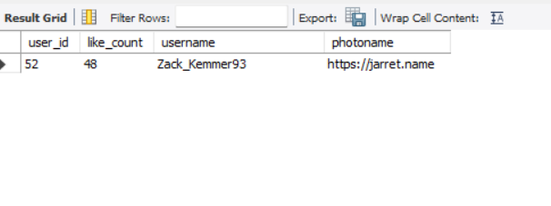

6. The investors want to know how many times does the average user post.

Ans:

SELECT p.user_id , u.username, AVG(p.id) as AveragePost FROM photos p

inner join users u on

p.user_id = u.id GROUP BY p.user_id;

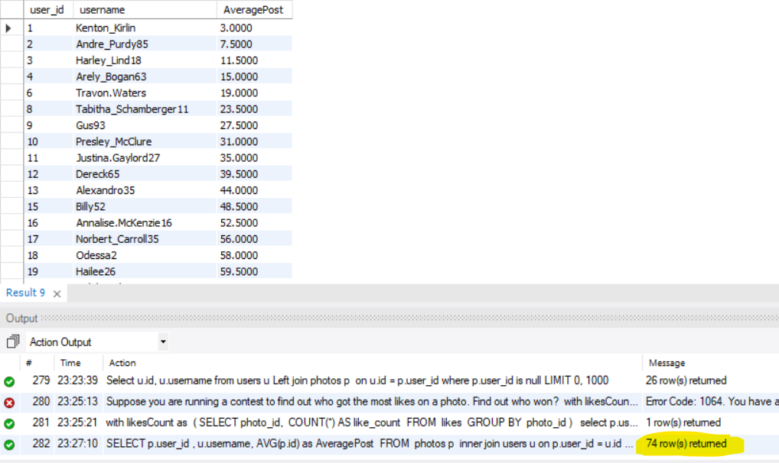

7. A brand wants to know which hashtag to use on a post, and find the top 5 most used hashtags.

Ans:

With tagcount

as

(select t.tag_Name, count(*) as tag_Count from photo_tags pt

inner join tags t

on t.id= pt.tag_id

group by t.tag_Name )

select * from tagcount order by tag_count desc limit 5

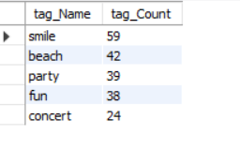

8. To find out if there are bots, find users who have liked every single photo on the site.

Ans:

Select Concat(username) as Username from users where id in (select user_id from comments) order by username;

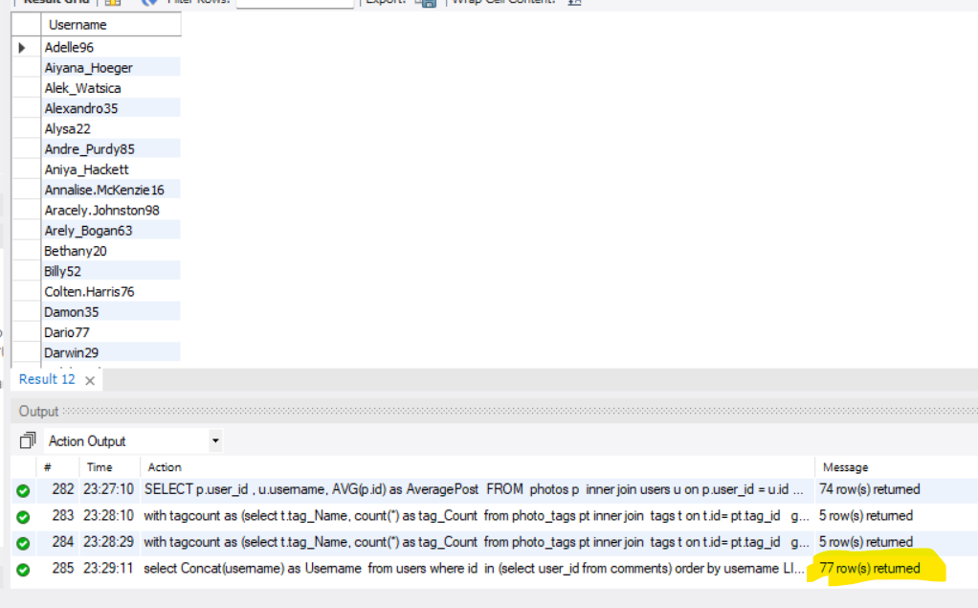

9. To know who the celebrities are, find users who have never commented on a photo.

Ans:

Select u.id, u.username from users u left join comments c

on u.id = c.user_id

where c.user_id is null order by u.id;

or

select * from users where id not in (select user_id from comments) 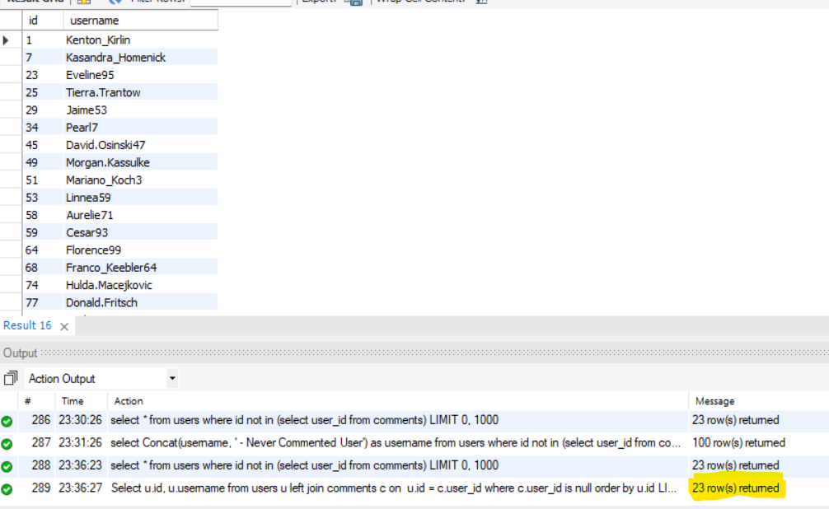

10. Now it's time to find both of them together, find the users who have never commented on any photo or have commented on every photo.

Ans:

select Concat(username, ' - Never Commented User') as username from users where id not in (select user_id from comments)

union all

select Concat(username, ' - Commented User') as Username from users where id in (select user_id from comments) order by username;

